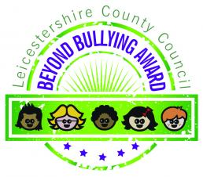

**Anti-Bullying Charter**

**Teachers Should:**

Be approachable

Try to spot the signs quickly

Talk to children firmly when dealing with bullies

Make children feel safe

Pay attention to bullying and places where bullying could happen

Realise it can take courage to talk about bullying

Work together to stop bullying

**Children should:**

**Tell someone they trust and speak out**

**Support each other & offer a listening ear**

**Report any bullying they see**

**Treat people how they like to be treated**

**Stay away from bullies and walk away**

**Stay away from places where bullying could happen**

**Remember school advice about bullies**

Recognise Bullying

**Bullying is repeated, aggressive behaviour intended to hurt another person, physically or mentally.**

**Bullying can take many forms and it may not be easy to recognise.**

**Bullying usually has these common features:**

**INTENT - it is deliberate!**

**REPEATED - it happens more than once**

**HARMFUL - it causes physical or emotional damage!**

**IMBALANCE - it is difficult for those being bullied to defend themselves**

)