**Acceptable Use Statement for pupils**

As pupils at Sketchley Hill Primary School, we want you to enjoy using the computers within our school.

It is very important that you:

**Always** look after the equipment



Be **kind** to one another, **sharing** the equipment nicely and fairly



Make sure you use **kind language** when talking to others through the computer



Only use websites or play games that your teacher has **allowed** you to use



Tell your teacher if anything or anyone makes you **feel uncomfortable** or if there is a problem



**Do not** bring to school any mobile phone or tablet from home (unless agreed otherwise with the school).



**Remember** not everything you read on the Internet may be true

Remember that sometimes attachments can contain **viruses or bugs** so only open attachments from people you know.



**I UNDERSTAND THAT THIS IS IMPORTANT, SO I PROMISE TO:**

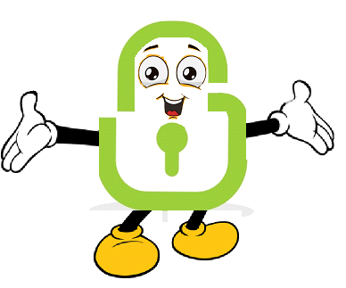

**LOCKI SAYS  
KEEP SAFE**

|  |  |
| --- | --- |
| tick icontick icon | Only use the Internet and email when an adult is nearby |
| tick icontick icon | Only click on icons and links when I know they are safe |
| tick icon | Only send friendly and polite messages |
| tick icon | Never share my usernames and passwords |
| tick icontick icon | Always tell an adult if I see something I don’t like on a screen  tick icon |