Parents Online Safety Meeting
3rd December 2018

This term, we held a Parents and Carers Online Safety meeting here at Sketchley. A leading national Online Safety trainer and advisor, Traci Good, led the presentation. Traci has worked with many schools up and down the country, supporting parents and carers in keeping their children safe at home when using online technology. The meeting gave the parents an insight into the ever-changing technological world and an awareness of some of the dangers children may be exposed to. Traci shared important tips and advice with the parents and carers to ensure that their children are using online gaming, social media and the internet in a safe way.
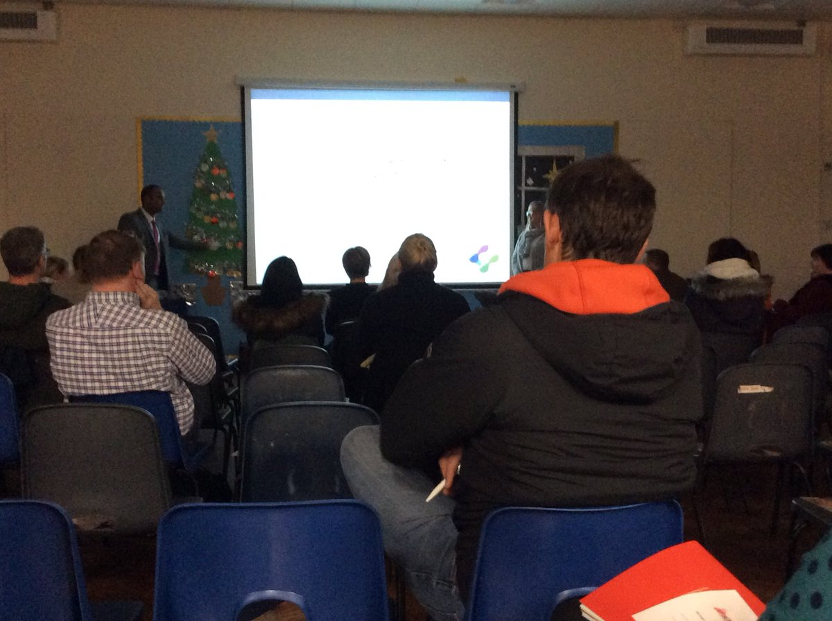

Here are some of the comments parents made at the end of the presentation:
- 'Very useful. Lots I didn't know. I will be sure to educate & lock down my child's devices.'
- 'Good session! Lots of useful info and hints & tips. Glad I came, thank you.'
- 'Incredibly useful session! All parents should hear this information. Very informative, thank you.'
- 'Very informative.'
- 'Really informative with some quite shocking stats & a lot of apps that I wasn't aware of. My daughter is KS1 but now I feel a bit more prepared.'
- 'Thank you for a great presentation.'
- 'Very helpful. I didn't even know half of the things existed that was discussed.'
- 'Helpful and informative. Shame the turnout was lower than expected as all parents should be aware.'
- 'Really informative. Keen to learn more about settings for TV etc.'
- 'The session was really informative, focusing on the good and bad of my child using the internet. Thank you for this valuable information.'
- 'Very interesting and insightful. Thank you!'
- 'Brilliant! Very informative.'
- 'Really informative. Very glad I came to this session.'
- 'Really insightful and useful information. Thank you.'
- 'Very informative thank you. I was surprised how much I didn't Know.'
- 'Excellent content. Very useful.'

Thank you to all of the parents and carers that attended the session.
If you need any more information regarding this, please click on the links below.
http://esafetytraining.co.uk/parents/

